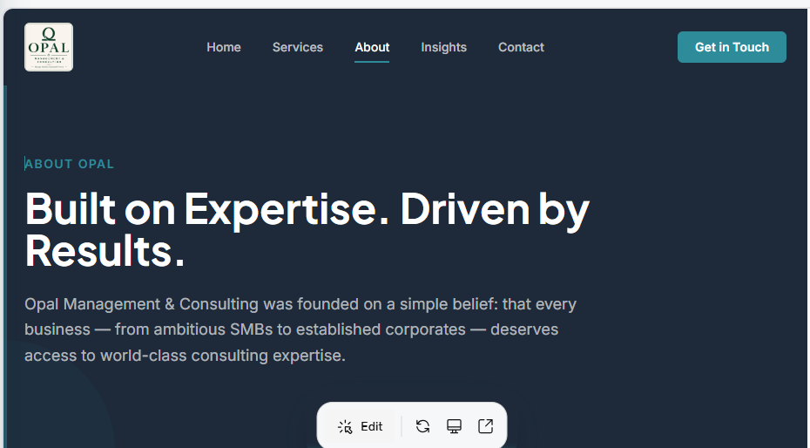
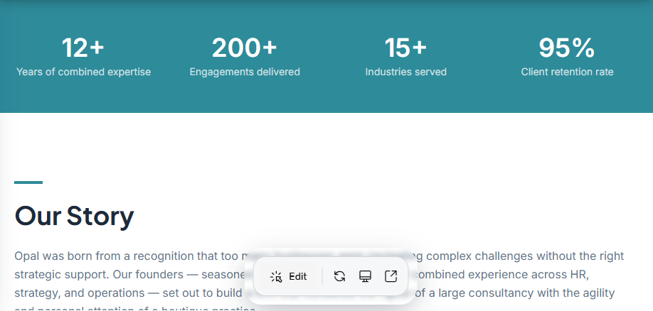
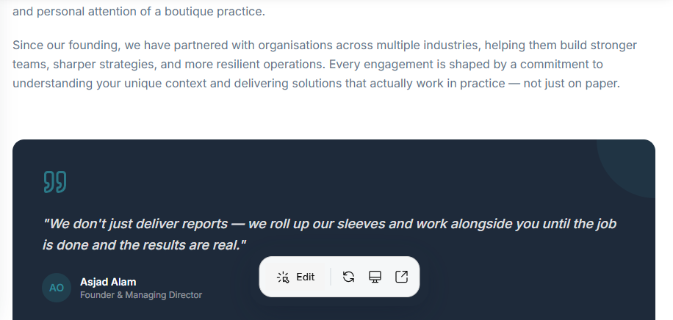
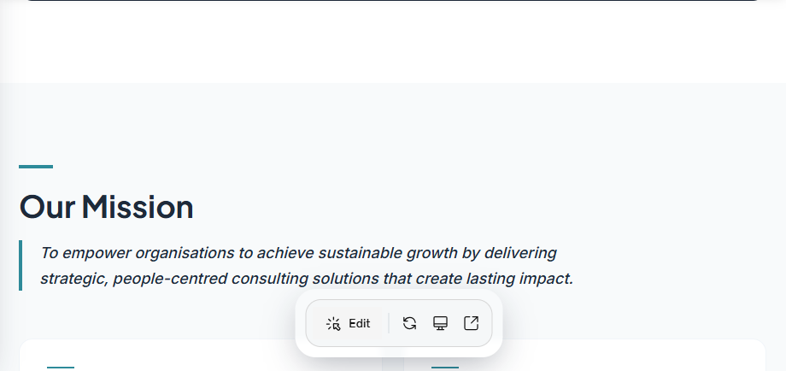
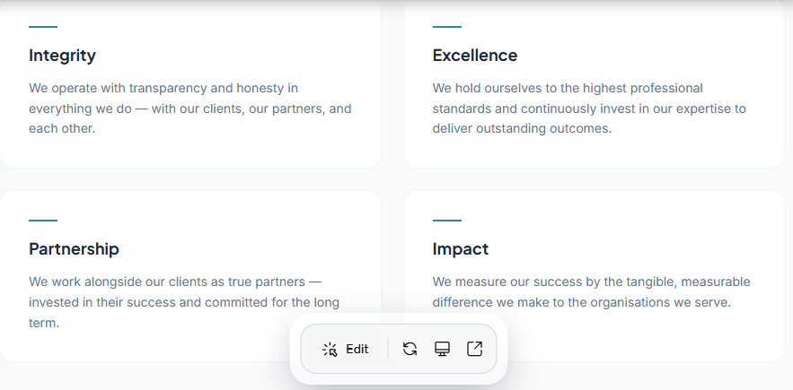
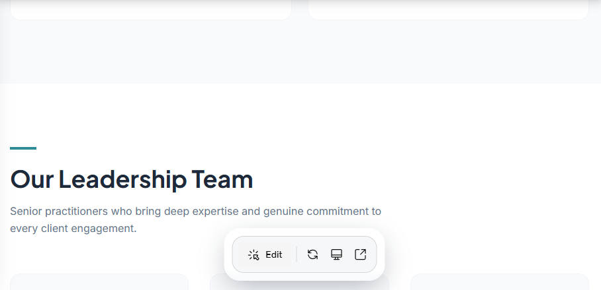
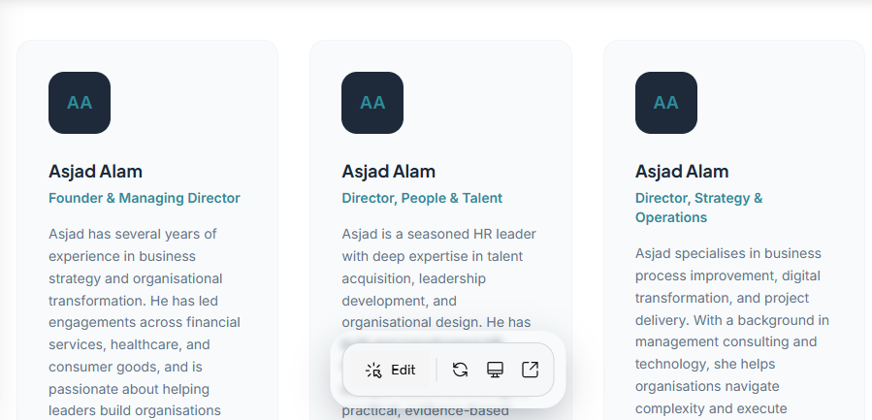
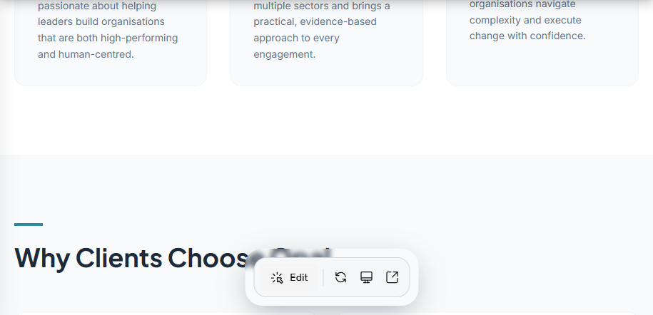
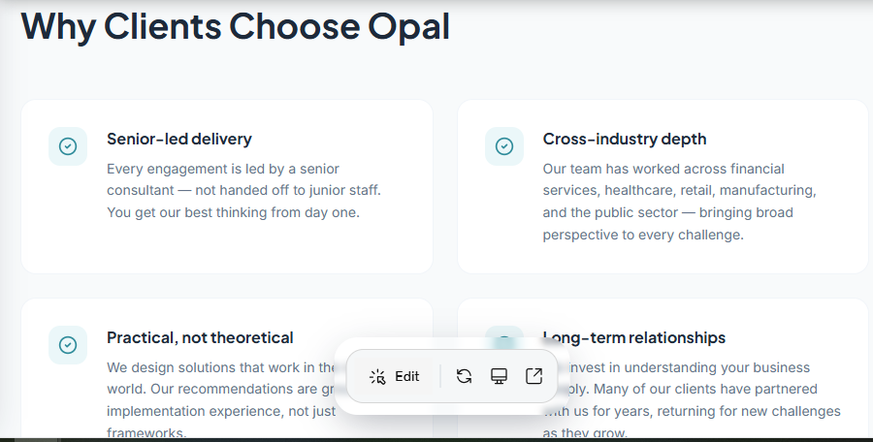
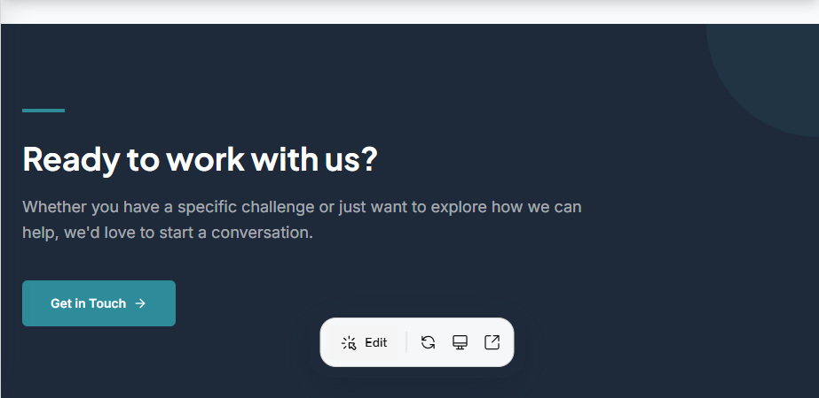
Service Section: Writing Content
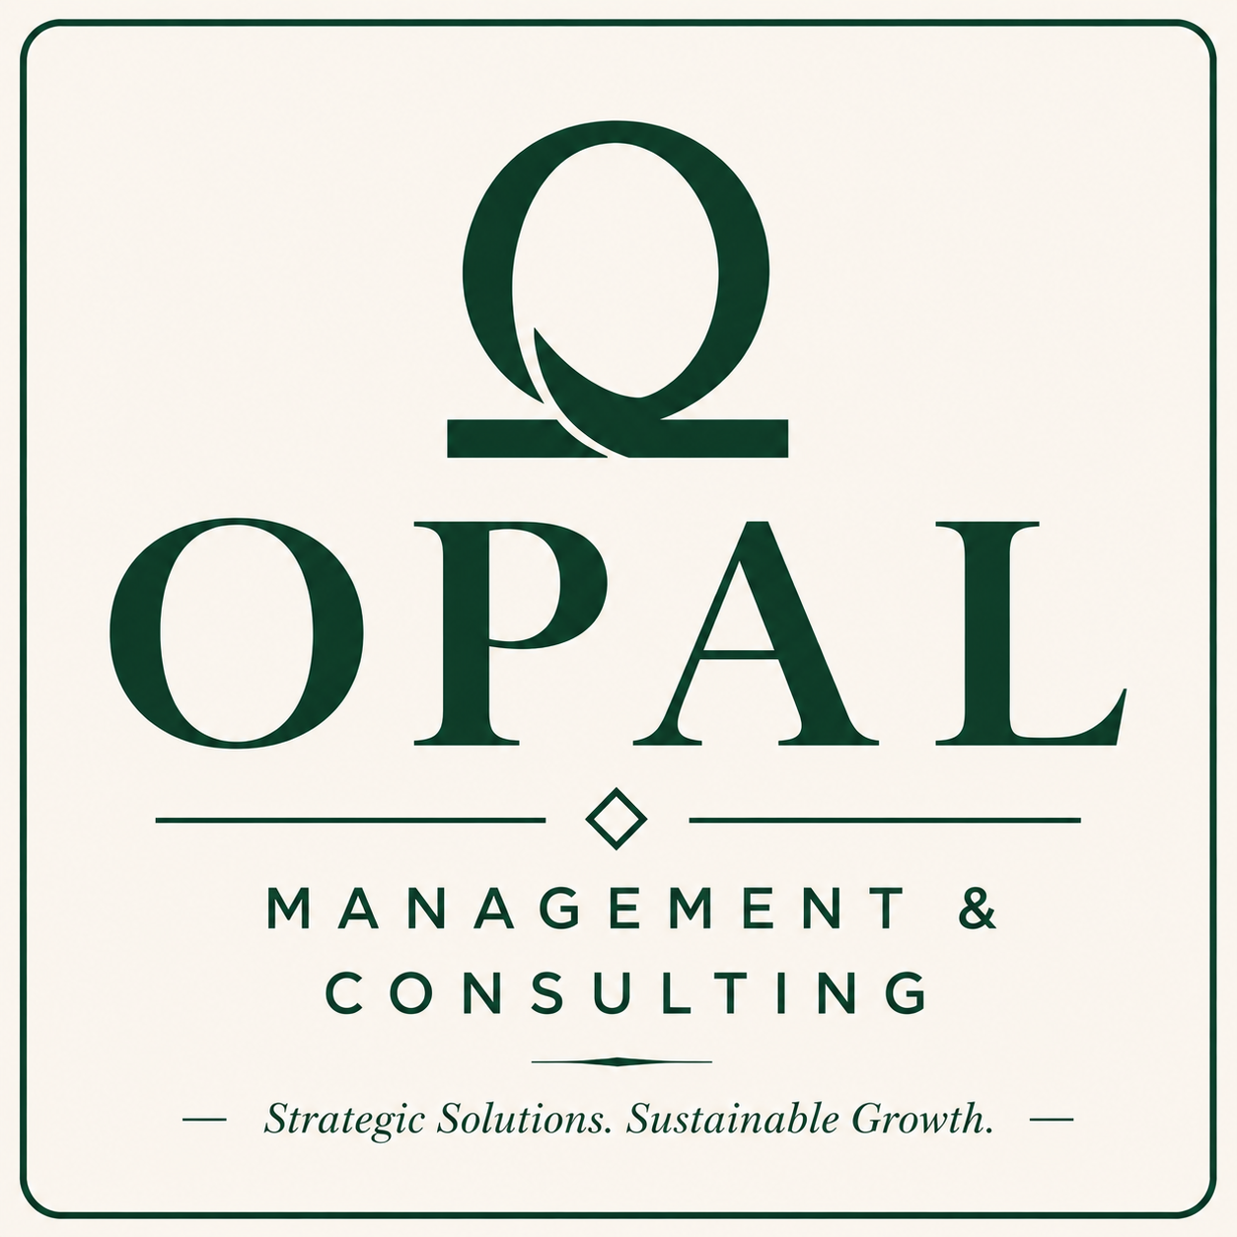

HomeServicesAboutInsightsContact
Get in Touch
Our Services

Comprehensive Solutions for Every Stage of Your Business
From strategy to execution, we bring deep expertise across 13 specializations — tailored to the unique needs of corporates and growing SMBs.

People & Talent

HR Consulting
People strategies that power organisational success.
We design and implement HR frameworks that align your people practices with your business goals — from policy development to culture transformation. Our consultants bring both strategic depth and practical implementation experience.
- HR policy design and implementation
- Organisational structure and design
- Employee engagement and retention strategies
- HR audit and compliance review
Ideal for
HR leaders and business owners looking to build scalable, compliant people functions.

Recruitment & Talent Acquisition
The right people, in the right roles, at the right time.
We manage the full recruitment lifecycle — from job profiling and candidate sourcing to assessment and onboarding. Our talent specialists understand your culture and deliver candidates who truly fit, not just on paper.
- Executive and specialist search
- Volume and bulk recruitment campaigns
- Candidate assessment and psychometric profiling
- Employer branding and talent pipeline development
Ideal for
Businesses scaling rapidly or seeking hard-to-find specialist talent.

Corporate Training
Building capability at every level of your organisation.
Our customised training programmes are designed to close skill gaps, boost productivity, and build a culture of continuous learning. We deliver in-person, virtual, and blended formats across a wide range of functional and soft-skill topics.
- Needs analysis and training design
- Functional and technical skills training
- Soft skills and communication workshops
- Post-training evaluation and impact measurement
Ideal for
Organisations investing in workforce capability and employee development.

Leadership Development
Developing the leaders your business needs tomorrow.
We design structured leadership journeys that build self-awareness, strategic thinking, and the ability to inspire teams. From emerging managers to C-suite executives, our programmes are tailored to each leader's context and ambition.
- Leadership assessment and 360-degree feedback
- Executive coaching and mentoring
- Leadership pipeline and succession planning
- High-potential talent development programmes
Ideal for
Organisations building leadership bench strength and succession readiness.

Performance Management
Drive accountability. Reward excellence.
We design and implement performance management systems that align individual goals with organisational objectives, foster a culture of accountability, and enable meaningful conversations between managers and their teams.
- Performance framework and KPI design
- Appraisal system design and implementation
- Manager capability building for performance conversations
- Reward and recognition strategy alignment
Ideal for
Organisations seeking to build a high-performance culture with clear accountability.

Strategy & Operations

Business Advisory
Strategic counsel that drives confident decisions.
We work alongside your leadership team to navigate complexity, identify growth opportunities, and build strategies that deliver lasting results. Our advisors bring cross-industry experience and a results-first mindset to every engagement.
- Strategic planning and roadmap development
- Market entry and expansion advisory
- Business model review and optimisation
- Stakeholder and board-level advisory support
Ideal for
CEOs, founders, and senior leadership teams facing strategic inflection points.

Project Management
Disciplined delivery. Every time.
We provide experienced project managers and PMO support to ensure your critical initiatives are delivered on time, on budget, and to scope. We bring structure, rigour, and clear communication to even the most complex programmes.
- Project planning, scoping, and governance
- Risk and issue management
- Stakeholder communication and reporting
- PMO setup and project portfolio management
Ideal for
Businesses running complex transformation programmes or lacking internal PM capacity.

Business Process Improvement
Streamline operations. Eliminate waste. Accelerate output.
We analyse your current processes, identify inefficiencies, and redesign workflows to improve speed, quality, and cost-effectiveness. Our approach combines lean methodologies with practical change management to ensure adoption.
- Process mapping and analysis
- Lean and Six Sigma-informed improvement
- SOP development and documentation
- Change management and staff adoption support
Ideal for
Operations leaders seeking to reduce costs and improve service delivery.

Outsourcing Services
Scale efficiently. Focus on what matters most.
We provide flexible, scalable outsourcing solutions that allow your business to reduce overhead, access specialist expertise, and focus internal resources on core activities. From HR functions to back-office operations, we deliver with consistency and quality.
- HR and payroll outsourcing
- Back-office and administrative support
- Managed service delivery models
- Transition planning and knowledge transfer
Ideal for
Businesses seeking to reduce fixed costs and access specialist capabilities on demand.

Business Support Services
Operational support that keeps your business moving.
We provide a range of flexible business support services to help organisations run smoothly — from executive assistance and office management to coordination and administrative functions. Reliable, professional, and tailored to your needs.
- Executive and administrative support
- Office and facilities coordination
- Event and meeting management
- Business continuity and operational support
Ideal for
Growing businesses that need reliable operational support without the overhead of full-time hires.

Transformation & Compliance

Digital Transformation
Technology-led change, delivered with clarity.
We guide organisations through the complexity of digital transformation — from strategy and technology selection to implementation and change adoption. We ensure your digital investments deliver real business value.
- Digital maturity assessment and roadmap
- Technology selection and vendor management
- Change management and digital adoption
- Data strategy and analytics enablement
Ideal for
Organisations modernising legacy systems or building digital-first capabilities.

Compliance & Governance
Protect your business. Build stakeholder confidence.
We help organisations build robust compliance frameworks and governance structures that reduce risk, meet regulatory requirements, and build trust with stakeholders. Our advisors bring deep regulatory knowledge across multiple sectors.
- Regulatory compliance assessment and gap analysis
- Policy and procedure development
- Corporate governance framework design
- Board and committee advisory support
Ideal for
Regulated industries and organisations seeking to strengthen governance and reduce risk.

AI Consulting
Harness the power of AI — strategically, responsibly, and at scale.
We help organisations understand, adopt, and operationalise artificial intelligence in ways that create real business value. From AI readiness assessments to implementation roadmaps and governance frameworks, we guide you through every stage of your AI journey — ensuring your investments are grounded in strategy, not hype.
- AI readiness assessment and opportunity mapping
- AI strategy and implementation roadmap
- AI governance, ethics, and risk frameworks
- Workforce AI adoption and change management
Ideal for
Leadership teams looking to leverage AI for competitive advantage while managing risk and building internal capability.

Not sure which service fits your needs?
Let's have a conversation. We'll help you identify the right solution for your specific challenges.
Talk to an Advisor

Your trusted partner in business growth. We help corporates and SMBs unlock their full potential through strategic consulting and operational excellence.

Our Services
- Business Advisory
- HR Consulting
- Recruitment & Talent Acquisition
- Corporate Training
- Leadership Development
- Project Management

More Services
- Business Process Improvement
- Digital Transformation
- Compliance & Governance
- Outsourcing Services
- Business Support Services
- Performance Management

Quick Links
- Home
- Services
- About Us
- Insights
- Contact

Get in Touch
- asjad.alam@opalmngmt.com
- +918796659492
- 123 Business Avenue,
Suite 400, New York, NY
Start a Conversation
© 2026 Opal Management & Consulting. All rights reserved.
Privacy PolicyTerms of Service

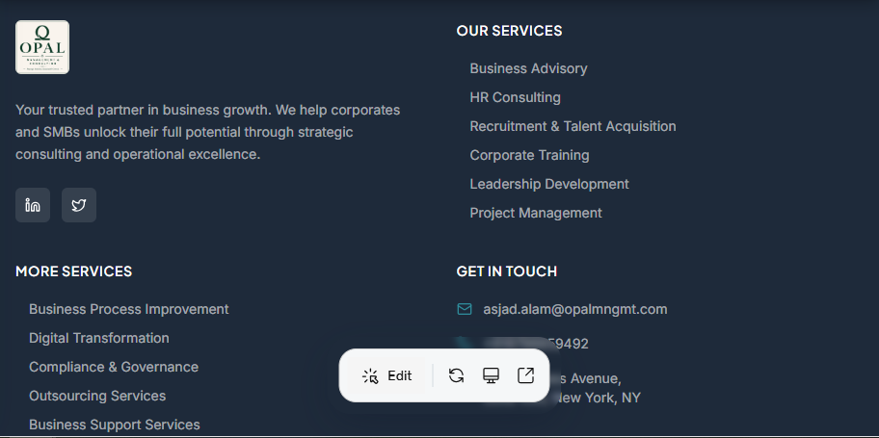

About Section: Writing Content

.
HomeServicesAboutInsightsContact
Get in Touch
About Opal

Built on Expertise. Driven by Results.
Opal Management & Consulting was founded on a simple belief: that every business — from ambitious SMBs to established corporates — deserves access to world-class consulting expertise.
12+
Years of combined expertise
200+
Engagements delivered
15+
Industries served
95%
Client retention rate

Our Story
Opal was born from a recognition that too many businesses were navigating complex challenges without the right strategic support. Our founders — seasoned consultants with decades of combined experience across HR, strategy, and operations — set out to build a firm that combines the rigour of a large consultancy with the agility and personal attention of a boutique practice.
Since our founding, we have partnered with organisations across multiple industries, helping them build stronger teams, sharper strategies, and more resilient operations. Every engagement is shaped by a commitment to understanding your unique context and delivering solutions that actually work in practice — not just on paper.
"We don't just deliver reports — we roll up our sleeves and work alongside you until the job is done and the results are real."
AO
Asjad Alam
Founder & Managing Director

Our Mission
To empower organisations to achieve sustainable growth by delivering strategic, people-centred consulting solutions that create lasting impact.

Integrity
We operate with transparency and honesty in everything we do — with our clients, our partners, and each other.

Excellence
We hold ourselves to the highest professional standards and continuously invest in our expertise to deliver outstanding outcomes.

Partnership
We work alongside our clients as true partners — invested in their success and committed for the long term.

Impact
We measure our success by the tangible, measurable difference we make to the organisations we serve.

Our Leadership Team
Senior practitioners who bring deep expertise and genuine commitment to every client engagement.
AA

Asjad Alam
Founder & Managing Director
Asjad has several years of experience in business strategy and organisational transformation. He has led engagements across financial services, healthcare, and consumer goods, and is passionate about helping leaders build organisations that are both high-performing and human-centred.
AA

Asjad Alam
Director, People & Talent
Asjad is a seasoned HR leader with deep expertise in talent acquisition, leadership development, and organisational design. He has built and transformed HR functions at scale across multiple sectors and brings a practical, evidence-based approach to every engagement.
AA

Asjad Alam
Director, Strategy & Operations
Asjad specialises in business process improvement, digital transformation, and project delivery. With a background in management consulting and technology, she helps organisations navigate complexity and execute change with confidence.

Why Clients Choose Opal

Senior-led delivery
Every engagement is led by a senior consultant — not handed off to junior staff. You get our best thinking from day one.

Cross-industry depth
Our team has worked across financial services, healthcare, retail, manufacturing, and the public sector — bringing broad perspective to every challenge.

Practical, not theoretical
We design solutions that work in the real world. Our recommendations are grounded in implementation experience, not just frameworks.

Long-term relationships
We invest in understanding your business deeply. Many of our clients have partnered with us for years, returning for new challenges as they grow.

Ready to work with us?
Whether you have a specific challenge or just want to explore how we can help, we'd love to start a conversation.
Get in Touch

Your trusted partner in business growth. We help corporates and SMBs unlock their full potential through strategic consulting and operational excellence.

Our Services
- Business Advisory
- HR Consulting
- Recruitment & Talent Acquisition
- Corporate Training
- Leadership Development
- Project Management

More Services
- Business Process Improvement
- Digital Transformation
- Compliance & Governance
- Outsourcing Services
- Business Support Services
- Performance Management

Quick Links
- Home
- Services
- About Us
- Insights
- Contact

Get in Touch
- asjad.alam@opalmngmt.com
- +918796659492
- 123 Business Avenue,
Suite 400, New York, NY
Start a Conversation
© 2026 Opal Management & Consulting. All rights reserved.
Privacy PolicyTerms of Service

Insight Section: Writing Content

HomeServicesAboutInsightsContact
Get in Touch
Insights & Case Studies

Thinking That Drives Results.
Perspectives on strategy, people, and operations — plus real stories of how we have helped organisations transform and grow.
Featured
Case StudyJune 20268 min read

Scaling a Financial Services Firm Through Rapid Growth
When a mid-sized financial services company needed to double its headcount in 18 months while maintaining culture and compliance, Opal designed and delivered an end-to-end talent and operations strategy that made it possible.
Discuss a similar challenge
AllStrategyPeople & TalentOperationsTransformation
Case StudyMay 2026

Rebuilding a High-Performance Culture After a Merger
Two organisations, two cultures, one leadership team. We helped a post-merger retail group align its people strategy and rebuild engagement from the ground up.
6 min readRead more
InsightApril 2026

Five Strategic Mistakes Growing Businesses Make — and How to Avoid Them
Growth creates complexity. Here are the five strategic errors we see most often in scaling businesses, and the frameworks we use to help leaders navigate them.
5 min readRead more
Case StudyMarch 2026

Cutting Operational Costs by 22% Without Cutting Headcount
A manufacturing client was facing margin pressure. Through process redesign and lean methodology, we identified and eliminated waste — delivering significant savings within six months.
7 min readRead more
InsightFebruary 2026

Why Your Talent Strategy Is Your Business Strategy
In a tight labour market, the organisations that win are those that treat talent as a strategic asset — not an HR function. Here is what that looks like in practice.
4 min readRead more
Case StudyJanuary 2026

Leading a Digital Transformation in a Traditional Industry
A logistics company with 40 years of history needed to modernise its operations without losing what made it great. We guided the leadership team through a phased transformation that delivered results.
9 min readRead more
InsightDecember 2025

The Case for Scenario Planning in an Uncertain World
Most strategic plans assume a single future. We make the case for scenario planning as a core leadership discipline — and share a practical framework for getting started.
5 min readRead more

Stay ahead of the curve.
Get our latest insights and case studies delivered to your inbox — no noise, just thinking worth your time.

Contact Section: Writing Content

